SPECIFICATIONS

Voltage : 220-240V~50-60Hz
Power : 100W
Juicing cup capacity : 400ml Pulp container capacity : 350ml
Unit size : 120 x 100 x 310 mm
Bare weight : 1.00 kg
- The Unit is designed for household use only.
- Commercial users will not obtain the regular warranty as stated in the terms of the warranty card.
- This is not a toy. Please do not let children play with it or use it.
- Read all instructions before use carefully.
- Keep this instructions for ever.
IMPORTANT :

IMPORTANT SAFEGUARDS

- Make sure the electricity supply is suitable for this unit.
- This unit is intended for household use only. Do not use the unit at outdoors or for other purpose than intended.
- Use the unit only as described in this manual.
- To prevent from electrical shock, do not immerse the unit, cord set and plug into water.
- This is not a toy and not to be used by children. Close supervision is required when the unit is used near children.
- Ensure to unplug the unit when not in use, assembling or disassembling, and before cleaning.
- The continuous operation time of this product should be within 20 minutes.
- No-load or overloaded operation of machine is prohibited.
- Do not touch or move any moving parts during operation of machine.
- Do not use finger, spoon or chopsticks to push fruits or vegetables into the chute of machine. Only pusher is allowed.
- Do not open the unit when it is operating.
- Do not place the unit near any explosives, heated oven or hot surfaces.
- Operate the unit only on flat surface.
- Do not let the cords hang over the edge of table or the like.
- Please hold the plug to disconnect from the power socket.
- If the parts of product structure is found to be damaged (especially the safety device and power cord), please stop using and send it to service centre to be repaired by qualified technician.
- This product is not intended operated by persons (including children) with weak physical condition, slow reaction, mental retardation, lack of experience and common sense, unless they are under supervision or instruction by the person who is responsible for their safety.
- If the screw press should get obstructed, put the juicer in ‘rev’ mode for about 2 to 3 seconds to let it turn in the opposite direction. After this, try to let the screw turn in the right direction again.
- Don’t use the water that is warmer than 40°C to rinse the appliance parts
- Never fill the appliance with unknown foods.
- Make sure that the base of the unit does not get wet.
22.This appliance is suitable to be used in a household environment and in similar surroundings such as:
- Kitchen for personnel of shops, offices or other similar professional surroundings
- Farms
- Hotel or motel rooms and other surroundings with a residential character
- Guest rooms or similar
- Travel

Attention: This appliance cannot be used with an external timer or a separate remote control.
To avoid hazard of electric shock, unplug the unit from power outlet when not in use or before cleaning. If the supply cord is damaged, stop using immediately and bring it back to service centre for repair.
NOTE :
HINT:

This Juicer is not suitable for juicing very hard or fibrous and starchy fruits or vegetables such as Sugar Cane.

There are some fruits which contain too much starch to juice. They include Avocado,Bananas,Figs,Mango and Papaya,Dragon fruit,Strawberry,Grape without seeds.They will clog up the stainless steel sieve.

PARTS DIAGRAM
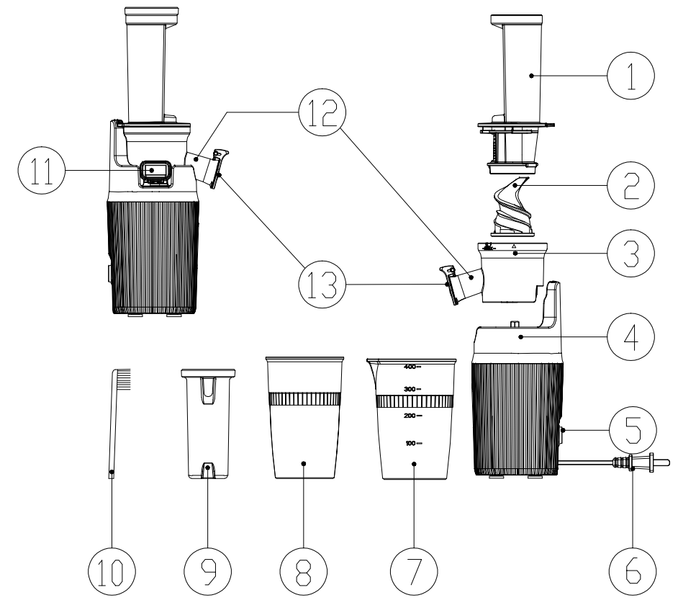

1 | Chute & Strainer Assembly | 8 | Pulp Container
2 | Squeezing Auger | 9 | Pusher
3 | Juicing Bowl | 10 | Cleaning Brush
4 | Power Base | 11 | Pulp Spout
5 | On / Off / Reverse Switch | 12 | Juice Spout
6 | Power Cord | 13 | Drip-stop cover
7 | Juice Container

USING FOR FIRST TIME

- Remove all packaging materials, plastic bags and labels.
- Make sure the electricity supply is 100-120V~60Hz or 220-240V~ 50-60Hz.
- Clean the Food Tray / Chute & Strainer Assembly / Squeezing Auger / Juicing Bowl / Pusher with Soapy water. Then rinse and dry thoroughly.

NOTE : DO NOT IMMERSE THE POWER BASE UNIT IN WATER.
- Assemble the parts per the instruction in the assembling method section.
- Connect the power cord to the power source.

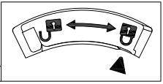
The unit is ready to use now.

ASSEMBLING METHOD

Please make sure the unit is not plugged and the switch is turned to “O” setting prior to assembling the machine.
- Position the squeezing bowl on the Power base aligning the position of the spouts and the axle. (Fig 1)
- Push the squeezing auger firmly into the center of the bowl, making sure that it touches down the bottom, or else the cover cannot be closed. (Fig 2)
- Position the chute on the bowl to align the ▲ to the “ ” and twist it clockwise until it clicks the safety lock. Please make sure that the arrow ▲ on “ ” the
cover aligns with the Lock graphic on the Bowl. (Fig 3)
- Place the juice container and the pulp container under the relevant spouts. (Fig 4)
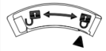
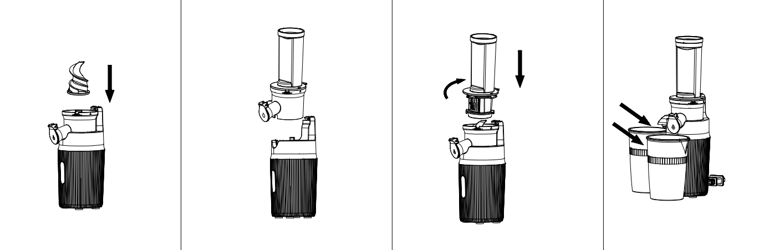

Fig 1
Fig 2
Fig 3
Fig 4

OPERATION INSTRUCTION

- Connect the unit with Power.
- Check and make sure all parts are well assembled in correct position.
- Make sure the machine is at off “O” position.
- Make sure the juice and pulp containers are in position.
- Make sure the juice spout cover is closed.
- Prepare the fruits or vegetables and cut them into pieces max 2cm x 5cm strips or 2cm x 2cm cubes.
- Put fruit strips/cubes into the chute.
- Press the switch to Setting “ - ” to start the juicing operation.
- Push the food down with the pusher only.
- In case of food stuck inside the Bowl, please switch to “R” reverse function instantly.
Please do not use the juicer continuously longer than 20 minutes.
NOTE :

Open & Close of Juice Spout Cover
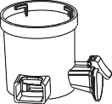
During the juicing process, you could keep the Drip-stop Cover closed before the juice is full in the juicing bowl. (Fig 5)

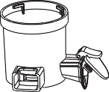
Juicer spout is opened
Juicer spout is closed

Fig 5

BENEFITS OF DRIP-STOP COVER :
- To stop dripping at the end of juicing.
- To mix the juice with different fruits and veggies.

USAGE TIPS :
- Remove hard pits or seeds prior to pressing to prevent possible damage to the squeezing screw.
- If mixed juices are to be made, please begin with harder fruit, and then squeeze the soft fruit.
- Please let the juicer to run for 30 seconds after the last ingredient was fed.

ATTENTION :
The juicer is not suitable for juicing very hard or fibrous and starchy fruits or vegetables such as Sugar Cane. There are some fruits which contain too much starch to juice.
Some examples are Avocado, Bananas, figs, Mango, Papaya, Dragon Fruit, Strawberry, Grape without seeds etc. They will clog up the stainless steel sieve.

DISASSEMBLING METHOD
If the juicer gets overheated, it will turn off automatically to protect the machine.
In this case, please turn the juicer off “O” . Wait 10 minutes to let the juicer cool down and then turn it on again.
NOTE :
To disassemble the unit after using and before cleaning. Please turn the juicer to “O” position and disconnect the juicer from power source.
Then, please follow the steps below :
- Remove the Juice and Pulp containers. (Fig 6)
- Remove the Chute. Turn the chute anti-clockwise until the ▲ aligns with the “ ” sign. (Fig 7)
- Remove the Squeezing Auger by pulling it out upward. If it is very hard, swing gently and pull. (Fig 8)
- Remove the Squeezing Bowl by lifting it upward vertically. (Fig 9)

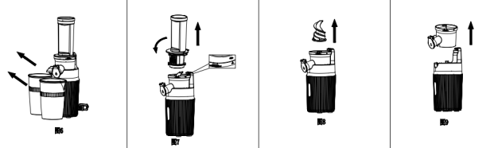

Fig 6 Fig 7

Fig 8 Fig 9

CLEANING & MAINTENANCE
Please wash the juicing parts every time immediately after each used, otherwise the pulp might stick tightly in Juicing Bowl & Squeezing Auger which will then affect the disassembly, cleaning and juicing performance.
IMPORTANT :
- Switch off and unplug the juicer.

2.Wash the disassembled parts (Fig 10) with water. If the meshes are clogged with pulp, please use the provided cleaning brush to remove the dregs.

CLEANING & MAINTENANCE

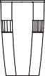
9 8 7

Attention:

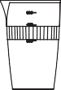
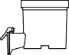
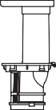
6 1+2 4

Fig 10
3

Do not use iron wire brush, abrasive or sharp object tool to clean the unit.
- Please do not use water above 40°C.
- Never clean any parts in dishwasher to avoid damage by hot water.
- In case there is any residues remained in the mouth of the pulp spout, please pull out the silicone valve as shown in (Fig 11) below and clean under running water.

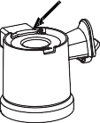
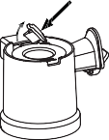
Silicone valve to open
Pull

Fig 11

Press the silicone valve to close it property and tightly after cleaning.
- To Clean the seal ring in the center of the squeezing bowl, please follow the steps as below :
  - Turn the Squeezing Bowl upside down for easier handling, Push the seal ring out with your thumb (Fig 12a) and clean it with water.
  - After Cleaning, please put it back to the center hole. The small ribbed surface should be should face upward (Fig.12b) Make sure the groove of the seal ring well fit in the squeezing bowl.
  - The big flat size of the seal ring will be inside while the small and ribbed side is outside the Squeezing Bowl. (Fig 12c)

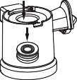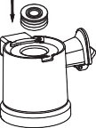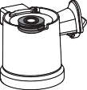

Fig 12a
Fig 12b
Fig 12c

- Do not put the Power Base into water for cleaning. Wipe it with damp cloth only.
- After cleaning, please dry the parts thoroughly and store them in a dry, cool place.

STORAGE

- Follow cleaning instructions to well maintain the unit before storage.
- Tidy up the power cord set.
- Keep the unit away from children’s easy access.
- Store the unit and the accessories at a dry, cool place.
Please make sure the unit and parts are dry before storing it.
NOTE :

USEFUL TIPS USEFUL TIPS

Item | Warning | Reason
1 | Not for Ice cube. | The ice cube is too hard. It may damage the squeezing parts.
2 | The ingredient with long fiber needs to be cut down to 2-5 cm thin strips or 2 x 2 cm cubes. | Long fiber food is easy to wind and block the spout.
3 | The peel and pits/seeds must be removed from oranges, lemons, grapefruit and melons before use. | The hard pit or seeds may damage the squeezing parts. The peel may block the spout of pulp.
4 | Do not use other accessory as a pusher. | It may damage the juicer and cause injury.
5 | Each juicing cycle not longer than 20 minutes. | Working over time may cause damage to the motor.
6 | Never put the spoon,chopsticks into the opening of the Chute, the juice and pulp spouts. | It may damage the juicer.

TROUBLE SHOOTING

Trouble | Cause | Solutions
The juicer stops running suddenly. | Too many ingredients put into the juicer. | Switch to “R” position instantly to make the ingredients return upwards. If the machine still stops running, please clean the machine before use.
 | Hard fruits or vegetables have not been cut in small pieces. | Hard fruits and vegetables  (such as carrot) shall be cut into thin strips or small cubes before putting into chute.
The juice yield is low or juice flows out of the main housing. | The Bowl and the silicone valve are not installed properly. | Please re-install the Bowl silicone valve by referring to the installation method.
Abnormal noise. | Parts cause extrusion sound during squeezing. | The sound is caused by extrusion of fruits and vegetables, which is normal phenomenon.
The Chute & Strainer Assembly cannot be opened. | There is too much pulps inside the bowl. | Press switch to “R” setting to eject the pulps backward.
 | There is hard foods stuck inside. | Press switch to “R” to eject the object backward.
 | The pulp mess is stuck. | Pour water into the Chute to soften the stuck pulp mess overnight.
The container & accessories are dyed after use. | Dyed parts are due to natural color of specific fruits/veggies. | This is natural color and unavoidable.

